PART I - TO BE COMPLETED BY PARENT

Student: ________________________________ D.O.B: __________ Teacher/Grade:_____________
Allergy to: ________________________________________________ Weight: ________________lbs.
Asthma: Yes (Higher risk for severe reaction) No
Note: Antihistamines and Inhalers are not to be depended upon to treat a severe reaction. USE EPINEPHRINE

PART II - TO BE COMPLETED BY LICENSED HEALTH CARE PROVIDER
Extremely reactive to the following allergens:_______________________________________________
Therefore:
⁯If checked, give epinephrine immediately if the allergen was LIKELY eaten, for ANY symptoms.
⁯ If checked, give epinephrine immediately if the allergen was DEFINITELY eaten, even if no symptoms are apparent.
- INJECT EPINEPHRINE IMMEDIATELY

- Call 911. Tell emergency dispatcher the person is having anaphylaxis and may need epinephrine when emergency respnders arrive.
- Consider giving additional medications following epinephrine:
- Antihistamine
- Inhaler (bronchodilator) if wheezing
- Lay the person flat, raise legs and keep warm. If breathing is difficult or they are vomiting, let them sit up or lie down on their side.
- If symptoms do not improve, or symptoms return, more doses of epinephrine can be given about 5 minutes or more after the last dose.
- Alert emergency contacts.
- Transport patient to ER, even if symptoms resolve. Patient should remain in ER at least 4 hours because symptoms may return.

FOR ANY OF THE FOLLOWING: SEVERE SYMPTOMS

LUNG Short of Breath, wheeze, repetitive cough

HEART Pale, blue, faint, weak pulse, dizzy, confused

THROAT Tight, hoarse, trouble breathing or swallowing

MOUTH Significant swelling (tongue or lips)

SKIN Many hives over body, widespread redness

SKIN Hives, itchy rashes, swelling

GUT Repetitive vomiting, severe diarrhea

OTHER Feeling something bad is about to happen,
anxiety, confusion

OR A COMBINATION of symptoms from different body areas.

MILD SYMPTOMS

NOSE Itchy or runny nose, sneezing

MOUTH Itchy mouth

SKIN A few hives around mouth/face mild itch

GUT Mild nausea/discomfort
FOR MILD SYMPTOMS FROM MORE THAN ONE SYSTEM AREA, GIVE EPINEPHRINE.

. FOR MILD SYMPTOMS FROM A SINGLE SYSTEM AREA, FOLLOW BELOW DIRECTIONS:
- Give antihistamine and/or inhaler, if ordered.
- Stay with student, alert emergency contact.
- Watch closely for changes. If symptoms worsen, give epinephrine.

Effective Dates: _______________________ Medication Orders (complete what is applicable):

Epinephrine Brand or Generic: __________________ Epinephrine Dose: 0.1 mg IM 0.15 mg IM 0.3 mg IM
Common Side Effects: _____________________________________________
Antihistamine Brand or Generic (Dose; Route): ___________________________________________________
Common Side Effects: _____________________________________________
Inhaler-bronchodilator if wheezing (Medication; Dose; Route): ___________________________________________
Common Side Effects: _____________________________________________

It is my professional opinion that this student SHOULD/SHOULD NOT (circle one) carry his/her epinephrine auto-injector.

___________________________/________________________________ _______________________ _______________
Licensed Health Care Provider Authorization (Print / Signature) Telephone Date

PART III - PARENT SIGNATURE REQUIRED

Student___________________________________ Date of Birth ______________Teacher/Grade_____________

PLEASE NOTE:
Administration of an oral antihistamine should be considered only if the student’s airway is clear and there is minimal risk of choking.
Antihistamines should NOT be used as a first line of treatment during an anaphylaxis episode. It will treat itching ONLY-it will not halt vascular collapse or swelling!
MONITORING
Stay with student, Call 911 and then emergency contact. Tell 911 epinephrine was given, request an ambulance with epinephrine. Note time when epinephrine was administered. A second dose of epinephrine can be given about 5 minutes or more after the last dose.

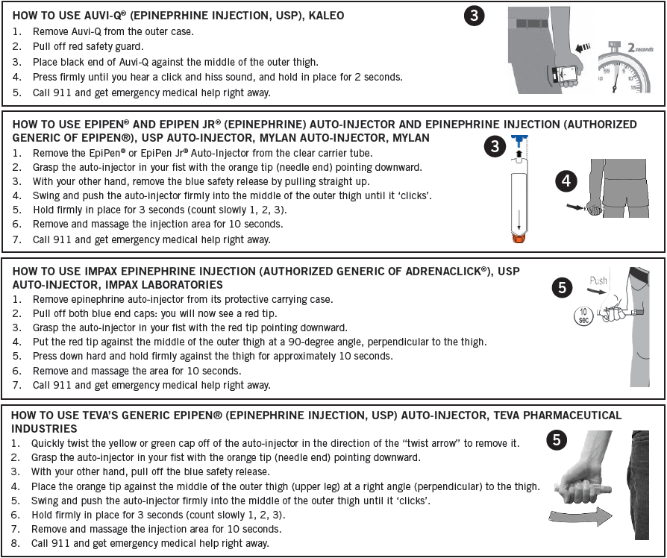
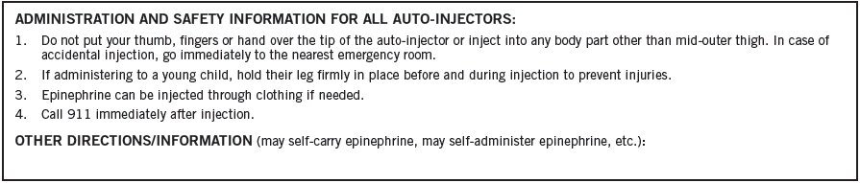

A food allergy response kit should contain at least two doses of epinephrine, other medications as noted by the student’s physician, and a copy of this action plan and treatment authorization. A kit must accompany the student if he/she is off school grounds (i.e., field trip).

Treat the person before calling emergency contacts. The first signs of a reaction can be mild, but symptoms can get worse quickly.

EMERGENCY CONTACTS:

Name/Relationship: ___________________________________________ Phone:__________________________
Name/Relationship: ___________________________________________ Phone:__________________________
Name/Relationship: ___________________________________________ Phone:__________________________

I hereby authorize for school personnel to take whatever action in their judgment may be necessary in providing emergency medical treatment consistent with this plan, including the administration of medication to my child. I understand the Virginia School Health Guidelines, Code of Virginia, 8.01-225 protects school staff members from liability arising from actions consistent with this plan.

_________________________________________________________ ______________________ ___________________
Parent / Guardian Authorization Signature Telephone Date

EPINEPHRINE AUTHORIZATION & ANTIHISTAMINE AUTHORIZATION
FOR USE WITH ALLERGY ACTION PLAN
Release and indemnification agreement
 | PART I TO BE COMPLETED BY PARENT OR GUARDIAN
☐ I hereby request designated school personnel to administer an epinephrine injection as directed by this authorization. I agree to release, indemnify, and hold harmless the designated school personnel, or agents from lawsuits, claim expense, demand or action, etc., against them for administering this injection, provided the designated school personnel comply with the Licensed Healthcare Provider (LHCP) or parent or guardian orders set forth in accordance with the provision of the attached Food Allergy and Anaphylaxis Care Plan. I am aware that the injection may be administered by a specifically trained non-health professional. I have read the procedures outlined on the back of this form and assume responsibility as required. I understand that emergency medical services (EMS) will always be called when epinephrine is given, whether or not the student manifests any symptoms of anaphylaxis. Two pre-measured doses will be needed in school.
☐ I hereby request designated school personnel to administer antihistamine and/or inhaled medication as directed by this authorization. I agree to release, indemnify, and hold harmless the designated school personnel, or agents from lawsuits, claim expense, demand or action, etc., against them for helping this student use medication, provided the designated school personnel comply with the Licensed Healthcare Provider (LHCP) or parent or guardian orders set forth in accordance with the provision of the attached Food Allergy and Anaphylaxis Care Plan. I have read the procedures outlined below this form and assume responsibility as required.
 | Student Name (Last, First, Middle) |  | Date of Birth
 | Allergies: | School: |  | School Year:
 | PART Il SEE PAGE 1 OF FOOD ALLERGY & ANAPHYLAXIS EMERGENCY CARE PLAN & TREATMENT AUTHORIZATION – Completed by Parent/Guardian and Student, if applicable
The injectable epinephrine dosage will be given as noted and detailed on the attached Allergy Action Plan
Check the appropriate boxes:
☐ Allergy Action Plan is attached with orders signed by Licensed Healthcare Provider
☐ It is not necessary for the student to carry his/her inhaler during school, the auto-injector and medication will be kept in the clinic or‬‬‬‬‬
other approved school location.
☐ The student is to carry an auto-injector during school and school sanctioned events with principal/school nurse approval. (An additional auto-injector, to be used as backup, is advised to be kept in the clinic or other approved school location and Appendix F-21B is signed) Additionally, I believe that this student has received information on how and when to use an auto-injector and that he or she demonstrates its proper use.
☐ The antihistamine medication will be given as noted and detailed on the attached Allergy Action Plan, if applicable.
☐ The inhaled medication will be given as noted and detailed on the attached Allergy Action Plan, if applicable.

___________________________________ _______________________________ ___________________ ____________
Parent or Guardian Name (Print or Type) Parent or Guardian (Signature) Telephone Date

___________________________________ _______________________________ ____________
Student Name (Print or Type) Student Signature (Required if Self Carry in addition to Appendix F-21B) Date

PART III TO BE COMPLETED BY LICENSED NURSE OR TRAINED ADMINISTRATOR OF MEDICATION
Check as appropriate:
☐ Part I and II are completed and signed.
☐ Food Allergy and Anaphylaxis Care Plan is completed in its entirety and signed by the LHCP and attached to this form.
☐ Auto injector, Antihistamine and Inhaled Medication, if applicable, are appropriately labeled.
☐ I have reviewed the proper use of an Auto Injector with the student and, ⁯ agree ⁯ disagree that student should self carry in school. Appendix F-21B is also reviewed and attached.
☐ If self-carry and parent does not supply 2nd Auto Injector for clinic, parent must sign acknowledge and refusal to send medication form, Appendix F-25.
___________________ Date any unused medication was collected by the parent or properly disposed. (Within one week after expiration of the physician order or on the last day of school).

_____________________________________________ _______________________________
Signature Date

PARENT INFORMATION ABOUT MEDICATION PROCEDURES

- In no case may any health, school, or staff member administer any medication outside the framework of the procedures outlined here in the Office of Catholic Schools Policies and Guidelines and Virginia School Health Guidelines manual.
- Schools do NOT provide routine medications for student use.
- Medications should be taken at home whenever possible. The first dose of any new medication must be given at home to ensure the student does not have a negative reaction.
- Medication forms are required for each Prescription and Over the Counter (OTC) medication administered in school.
- All medication taken in school must have a parent/guardian signed authorization. Prescription medications, herbals and OTC medications taken for 4 or more consecutive days also require a licensed healthcare provider’s (LHCP) written order. No medication will be accepted by school personnel without the accompanying complete and appropriate medication authorization form.
- The parent or guardian must transport medications to and from school.
- Medication must be kept in the school health office, or other principal approved location, during the school day. All medication will be stored in a locked cabinet or refrigerator, within a locked area, accessible only to authorized personnel, unless the student has prior written approval to self-carry a medication (e.g. inhaler, auto-injector). If the student self carries, it is advised that a backup medication be kept in the clinic. ). If a backup auto-injector is not supplied, please complete Appendix F-25.
- Parents/guardians are responsible for submitting a new medication authorization form to the school at the start of the school year and each time there is a change in the dosage or the time of medication administration.
- A Licensed Health Care Provider (LHCP) may use office stationery, prescription pad or other appropriate documentation in lieu of completing the Food and Anaphylaxis Care Plan. The following information written in lay language with no abbreviations must be included and attached to this medication administration form. Signed faxes are acceptable.
  - Student name
  - Date of Birth
  - Diagnosis
  - Signs or symptoms
  - Name of medication to be given in school
  - Exact dosage to be taken in school
  - Route of medication
  - Time and frequency to give medications, as well as exact time interval for additional dosages.
  - Sequence in which two or more medications are to be administered
  - Common side effects
  - Duration of medication order or effective start and end dates
  - LHCP’s name, signature and telephone number
  - Date of order
- All prescription medications, including physician’s samples, must be in their original containers and labeled by a LHCP or pharmacist. Medication must not exceed its expiration date.
- All Over the Counter (OTC) medication must be in the original, small, sealed container with the name of the medication and expiration date clearly visible. Parents/guardians must label the original container of the OTC with:
  - Name of student
  - Exact dosage to be taken in school
  - Frequency or time interval dosage is to be administered
- The student is to come to the clinic or a predetermined location at the prescribed time to receive medication. Parents must develop a plan with the student to ensure compliance. Medication will be given no more than one half hour before or after the prescribed time.
- Students are NOT permitted to self medicate. The school does not assume responsibility for medication taken independently by the student. Exceptions may be made on a case-by-case basis for students who demonstrate the capability to self-administer emergency life saving medications (e.g. inhaler, auto injector)
- Within one week after expiration of the effective date on the order, or on the last day of school, the parent or guardian must personally collect any unused portion of the medication. Medications not claimed within that period will be destroyed.

